CHAPTER 2
METHODOLOGY
2.1 BLOCK DIAGRAM
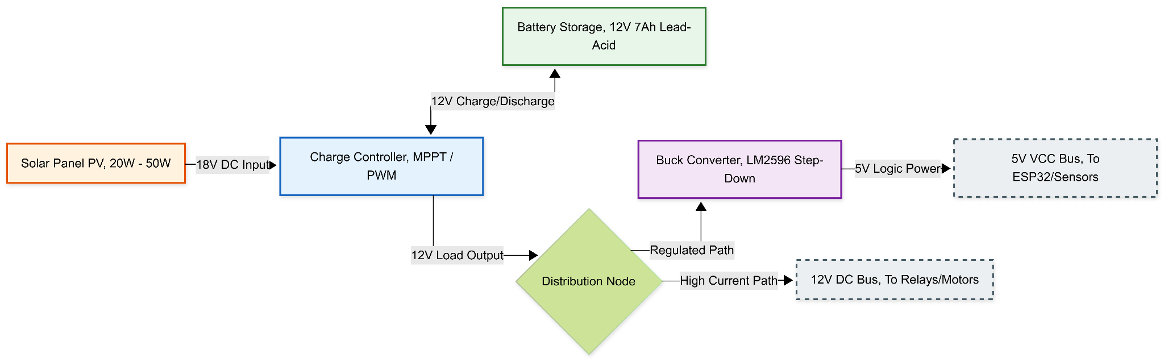
Figure 2.1 Power Generation and Regulation Subsystem
Figure 2.1 illustrates the architecture of the Power Subsystem, which serves as the foundational energy source for the entire WALRUS unit. The flow of energy begins at the Solar Panel (PV), which harvests solar irradiance and converts it into an unregulated DC voltage (typically 18V-21V). This raw energy is fed into the Charge Controller (MPPT/PWM), which acts as the primary voltage regulator; its dual role is to safely charge the 12V Lead-Acid Battery during peak sunlight hours and to draw from this storage during intermittent cloud cover or low-light conditions. The system utilizes a Distribution Node to split the power into two distinct voltage rails. The "High Current Path" delivers raw 12V directly to the electromechanical actuators (motors), ensuring they receive sufficient torque. Simultaneously, the "Regulated Path" passes through a Buck Converter (LM2596), which steps the voltage down to a stable 5V. This separation is critical to isolate the sensitive logic circuits from the electrical noise generated by the motors.
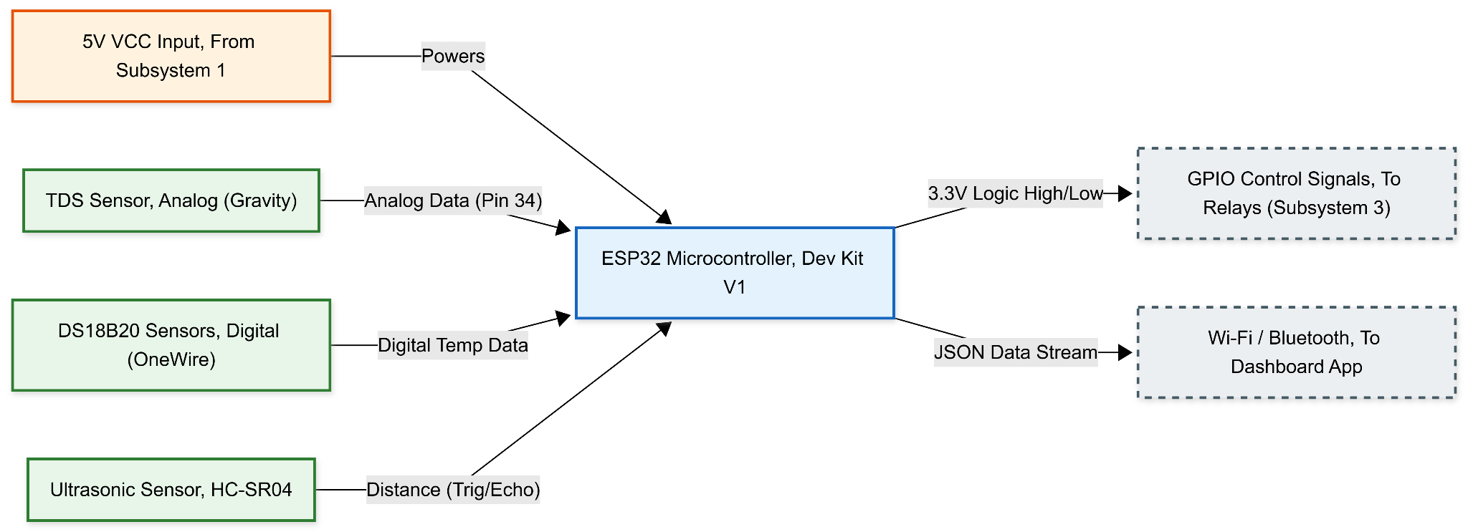
Figure 2.2 Control and Monitoring Subsystem
Figure 2.2 depicts the logical core of the device, centered around the ESP32 Microcontroller. This subsystem is responsible for data acquisition and signal processing. It receives a stable 5V supply from the Power Subsystem, which powers the internal 3.3V logic regulators. The diagram highlights three distinct sensor inputs: the Ultrasonic Sensor (HC-SR04), which provides distance data to calculate water levels; the DS18B20 Digital Sensors, which communicate precise thermal readings of the basin and condenser via the OneWire protocol; and the Analog TDS Sensor, which measures the electrical conductivity of the distillate to estimate purity. The ESP32 processes these inputs to generate two types of outputs: physical GPIO Control Signals (Logic High/Low) sent to the relay drivers, and a digital JSON Data Stream transmitted wirelessly via Wi-Fi/Bluetooth to the external dashboard for remote monitoring.
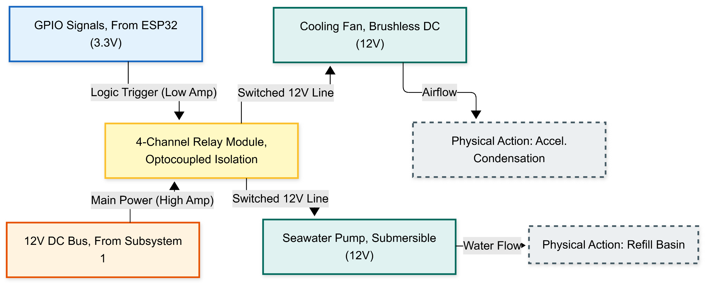
Figure 2.3 Electromechanical Actuation Subsystem
Figure 2.3 details the physical interface where digital logic is converted into mechanical work. This subsystem utilizes a 4-Channel Relay Module to achieve galvanic isolation, a safety feature that electrically separates the low-voltage (3.3V) signals of the microcontroller from the high-power (12V) circuit of the actuators. When the ESP32 triggers a specific channel, the relay closes the circuit, allowing 12V power to flow to the specific component. The Seawater Pump is activated to transfer fluid into the basin, resulting in the physical action of "Refilling." Conversely, the Cooling Fan is activated to blow ambient air across the condenser surface, resulting in "Accelerated Condensation." This block diagram demonstrates the system's capability to actively manipulate its physical environment based on the control logic.
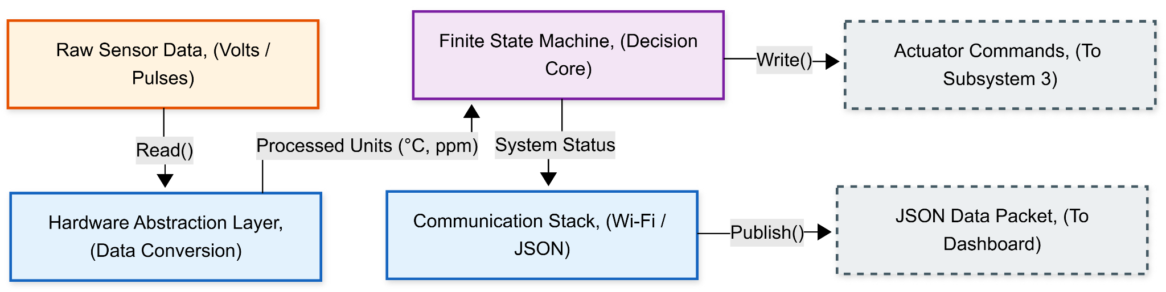
Figure 2.4 Firmware Architecture
Figure 2.4 represents the internal software structure programmed into the microcontroller, illustrating how data flows through the system's memory. The architecture is modularized into three layers. First, the Hardware Abstraction Layer (HAL) accepts raw electrical signals (voltage or pulse widths) from the sensors and converts them into human-readable engineering units (e.g., degrees Celsius, centimeters). Next, this processed data is fed into the Finite State Machine (FSM), which serves as the decision core; it evaluates the current state against pre-defined thresholds (e.g., "Is Temp > 50°C?") to determine the necessary system state (Idle, Refilling, or Distilling). Finally, the system status is passed to the Communication Stack, which serializes the data into a JSON payload and manages the transmission protocols required to send this packet to the external network.
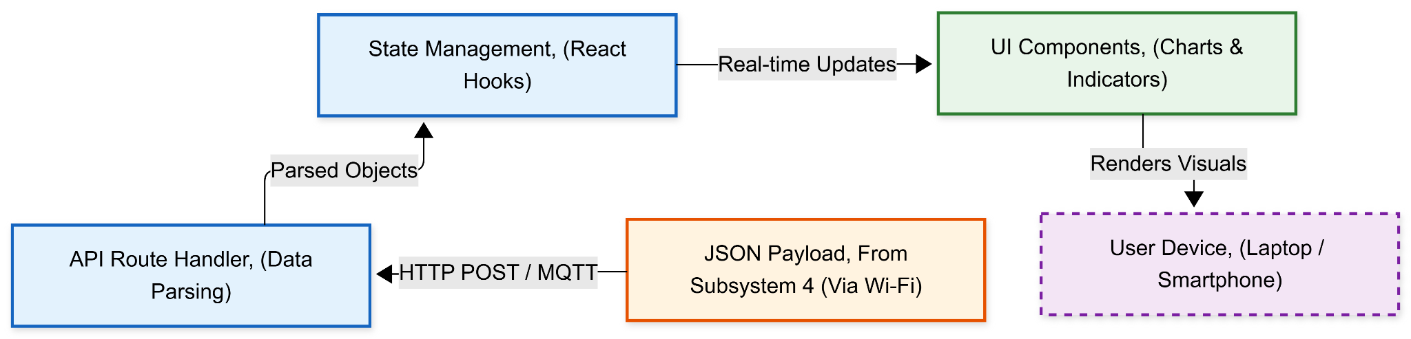
Figure 2.5 External Application and User Interface
Figure 2.5 outlines the software stack of the remote monitoring dashboard, built using the Next.js framework. The data flow initiates with the reception of the JSON Payload transmitted by the WALRUS unit via Wi-Fi. This data enters the application through an API Route Handler, which parses the incoming message and validates its structure. The valid data is then passed to the State Management engine (utilizing React Hooks), which holds the real-time status of the device. This state engine dynamically updates the UI Components, rendering visual elements such as line graphs for temperature history and status indicators for battery health. The final output is displayed on the User Device (Laptop or Smartphone), fulfilling the project's objective of providing accessible, real-time telemetry to the user.

2.2 PROJECT MANAGEMENT

2.2.1 Materials and Resources
Table 2.1 is a list of the hardware and software materials that were needed to build the Project WALRUS prototype. The materials were divided into three main subsystems: Electronics, Power and Mechanical.
The Electronics category was covered by the ESP32 microcontroller whose low power consumption and built-in Wi-Fi make it a good choice and specific sensors (TDS, Temperature, Ultrasonic) needed to monitor the distillation process. The Power subsystem deployed a solar photovoltaic system with battery storage to make sure the device can work off-grid. To facilitate the Mechanical structure, the condensing cover has been made to be made of clear acrylic to allow the maximum solar penetration and the marine grade sealant to be employed to keep the basin airtight thereby allowing efficient evaporation.

Material/Resource | Quantity | Cost
I. Electrical and Control
ESP32 Dev Kit V1 (Microcontroller) | 1 | 350
DS18B20 Waterproof Temp Sensor | 3 | 330
Analog TDS Sensor (Gravity Type) | 1 | 450
Ultrasonic Sensor (HC-SR04) + Resistors | 1 | 120
4-Channel Relay Module (5V) | 1 | 150
DC Buck Converter (LM2596) | 2 | 200
Prototype PCB & Connecting Wires | 1 set | 300
II. Solar Power System
Solar Panel (20W - 50W, 18V) | 1 | 1200
Solar Charge Controller (MPPT/PWM) | 1 | 500
12V 7Ah Lead Acid Battery | 1 | 750
DC Power Cables & Connectors | 1 set | 250
III. Mechanical Structure (Still)
Clear Acrylic Sheet (4ft x 4ft, 3mm) | 1 | 1800
Black Aluminum (Water Basin | 1 | 4000
Micro Submersible Pump (12V) | 1 | 150
DC Cooling Fan (12V) | 1 | 150
PVC Pipes, Wood Frame & Fittings | 1 lot | 1000
Marine Sealant (Silicone) & Adhesive | 2 tubes | 400
Black High-Temp Spray Paint | 2 cans | 300
Total Cost |  | 12250
Table 2.1 Materials and Resources

2.2.2 Gantt Chart
Table 2.2 illustrates the project timeline, broken down into weekly intervals from January to March. The schedule was designed to prioritize the parallel development of hardware and firmware in January, allowing the entire month of February for system integration and rigorous testing. The final weeks in March were dedicated to data analysis and the completion of the final thesis manuscript in preparation for the defense.

Task |  |  |  | November |  |  |  | December |  |  |  | January |  |  |  | February |  |  |  | March
 |  |  |  | 1 | 2 | 3 | 4 | 1 | 2 | 3 | 4 | 1 | 2 | 3 | 4 | 1 | 2 | 3 | 4 | 1 | 2 | 3 | 4
Increment 1: Design & Documentation
Topic Proposal & Approval
Drafting Chapter 1 (Introduction)
Drafting Chapter 2 (RRL) and System Architecture
Increment 2: Methodology & Procurement
Drafting Chapter 3 (Methodology)
Hardware Procurement
Bench Testing Phase
Physical Enclosure Assembly
Increment 3: Prototyping & Firmware
Firmware Development (Subsystem 4)
IoT Dashboard Integration (Subsystem 5)
System Calibration
Increment 4: Finalization & Field Testing
Field Validation Phase
Final Documentation
Table 2.2 Gantt Chart
2.3 PROTOTYPE DESIGN
Figure 2.6 illustrates the startup sequence of the Project WALRUS firmware, ensuring all hardware and communication protocols are established before autonomous operation begins. Upon powering the ESP32, the system first initializes essential internal peripherals (GPIO, ADC, UART, and Timers) followed by the external sensor array (Temperature, pH, DO, and EC). It then synchronizes the internal Real-Time Clock (RTC) and retrieves saved configuration setpoints from Non-Volatile Storage (NVS). The workflow then attempts to establish a Wi-Fi connection; depending on the outcome, the system sets its network mode to either "Online" or "Local/Offline," ensuring functionality even without internet access. Finally, a diagnostic check validates the sensor readings: if all sensors are healthy, the system transitions to the Main Loop (Connector A); otherwise, it diverts to Safe Mode (Connector S) for troubleshooting.

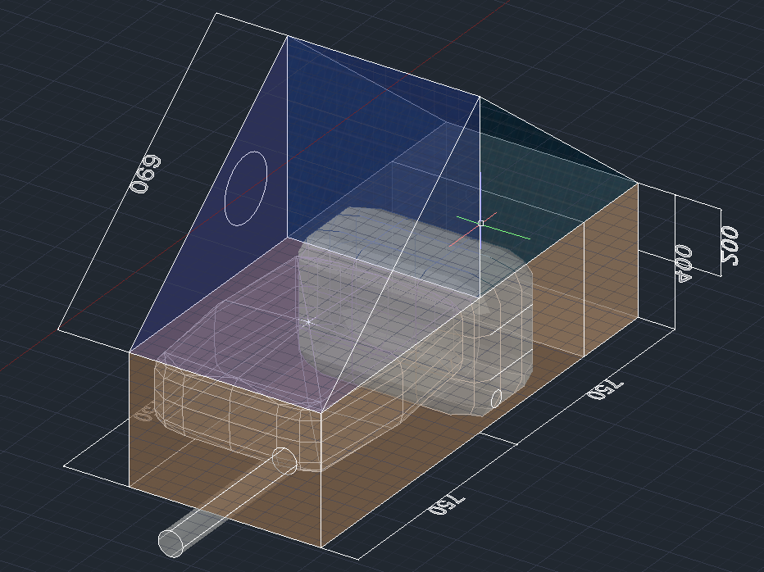
Figure 2.6 Prototype Design
2.4 CIRCUIT DESIGN
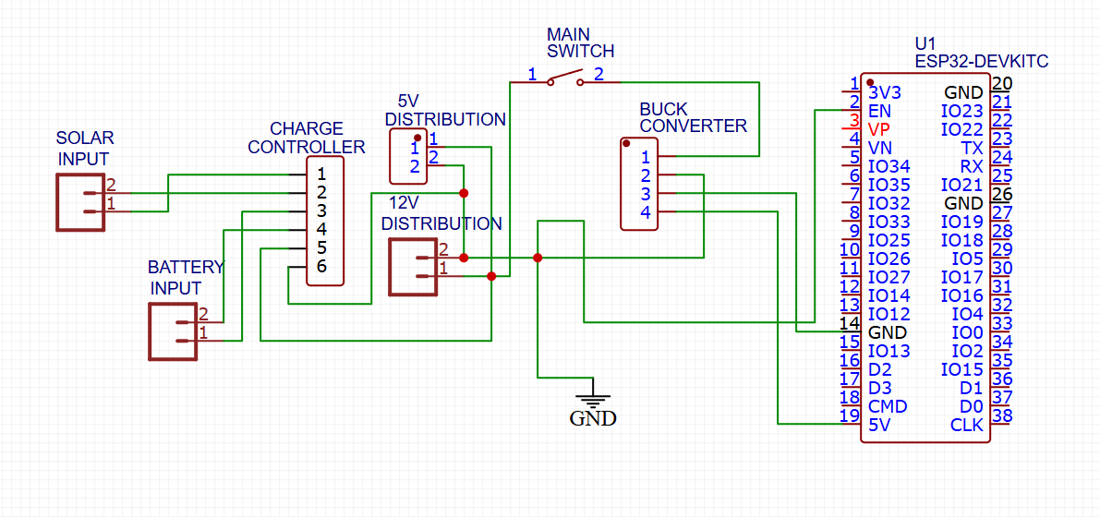
Figure 2.7 Subsystem 1: Power Generation and Regulation
The Power Generation and Regulation subsystem functions as the foundational energy plant for the autonomous purification unit, ensuring continuous operation independent of the electrical grid. As illustrated in Figure 2.7, the circuit is designed around a central PWM (Pulse Width Modulation) Charge Controller, which acts as the primary power manager. It regulates the variable DC input harvested from the 50W Photovoltaic (PV) Panel, preventing battery overcharging during peak sunlight hours and blocking reverse current leakage at night. This regulated energy is stored in a 12V 7Ah Lead-Acid Battery, sized to sustain system operations for at least 4–6 hours during periods of low solar irradiance.

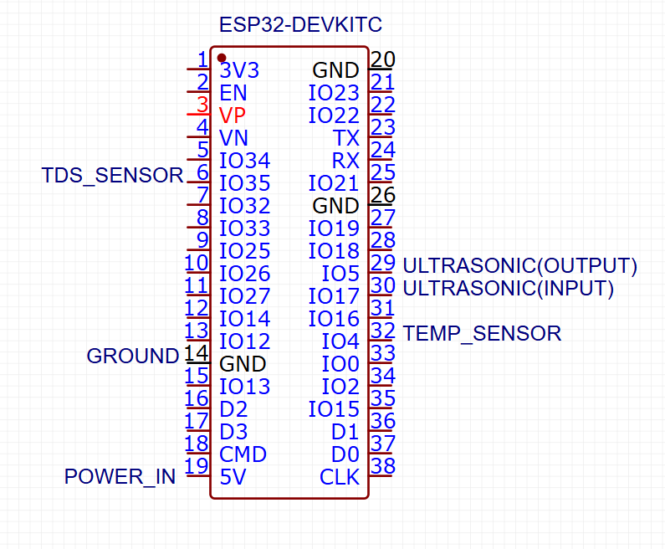
Figure 2.8 Subsystem 2: Control and Sensor
This subsystem acts as the central processing unit of the Project WALRUS prototype. As shown in Figure 2.8, the core component is the ESP32-DEVKIT-V1 Development Board (38-Pin Version), selected for its dual-core processing capabilities and integrated Wi-Fi stack for IoT telemetry. The microcontroller is powered via the 5V (VIN) pin, receiving regulated power from Subsystem 1.
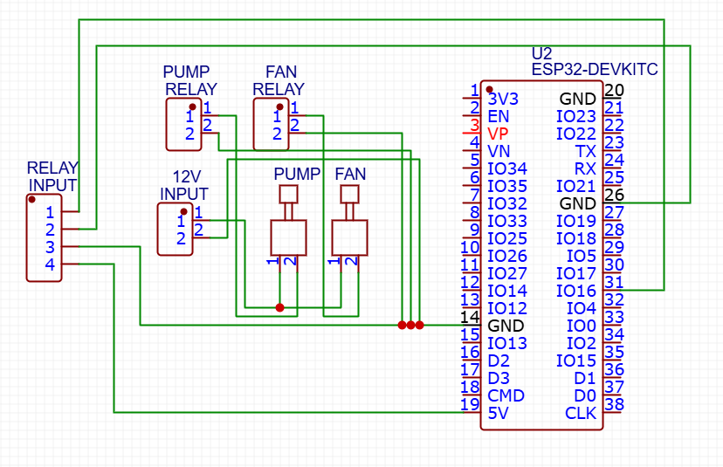
Figure 2.9 Subsystem 3: Electromechanical Driver Circuit
The Electromechanical Driver Subsystem is responsible for executing the physical actuation commands generated by the central processor. As illustrated in Figure 2.9, this circuit utilizes Optical Isolation Relays to interface the low-voltage logic (3.3V) of the ESP32 with the high-current power rail (12V) required by the actuators.

2.5 PROGRAM FLOWCHART
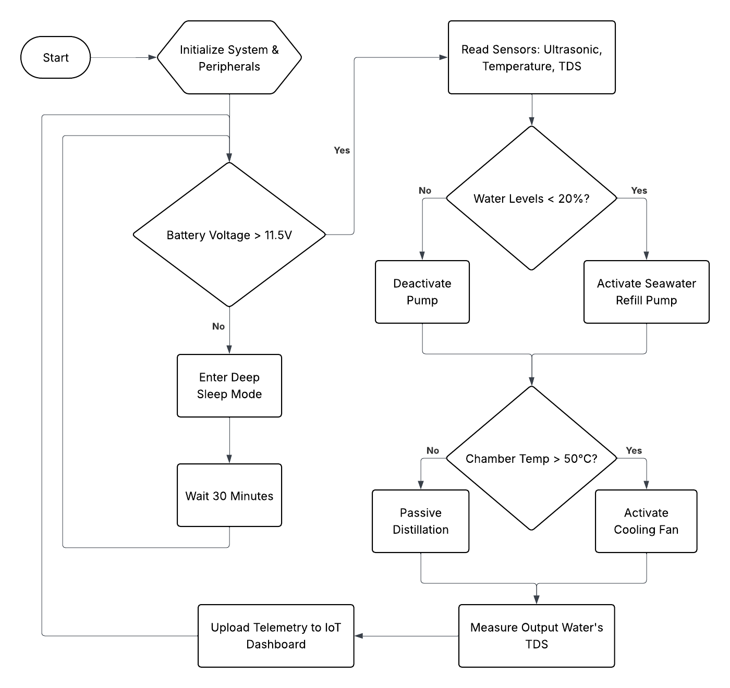
Figure 3.0 System Operational Flowchart
As depicted in Figure 3.0, the autonomous operation of the Project WALRUS unit begins with a critical initialization sequence and Power Audit. Upon startup, the system verifies that the battery voltage exceeds the safe operating threshold of 11.5V; if power is insufficient, the device enters a protective "Deep Sleep" mode for 30 minutes to prevent permanent battery degradation. Once operational stability is confirmed, the system enters its primary Sensing and Actuation Loop. The process prioritizes resource management by first assessing the basin volume via the Refill Logic, which triggers the seawater pump only if levels fall below 20%. Simultaneously, the Thermal Management Logic monitors the internal chamber temperature, engaging the active cooling fan if the reading exceeds 50°C to accelerate condensation. The cycle concludes with a Telemetry Phase, where water quality data (TDS) is measured and transmitted to the IoT dashboard before the loop repeats.
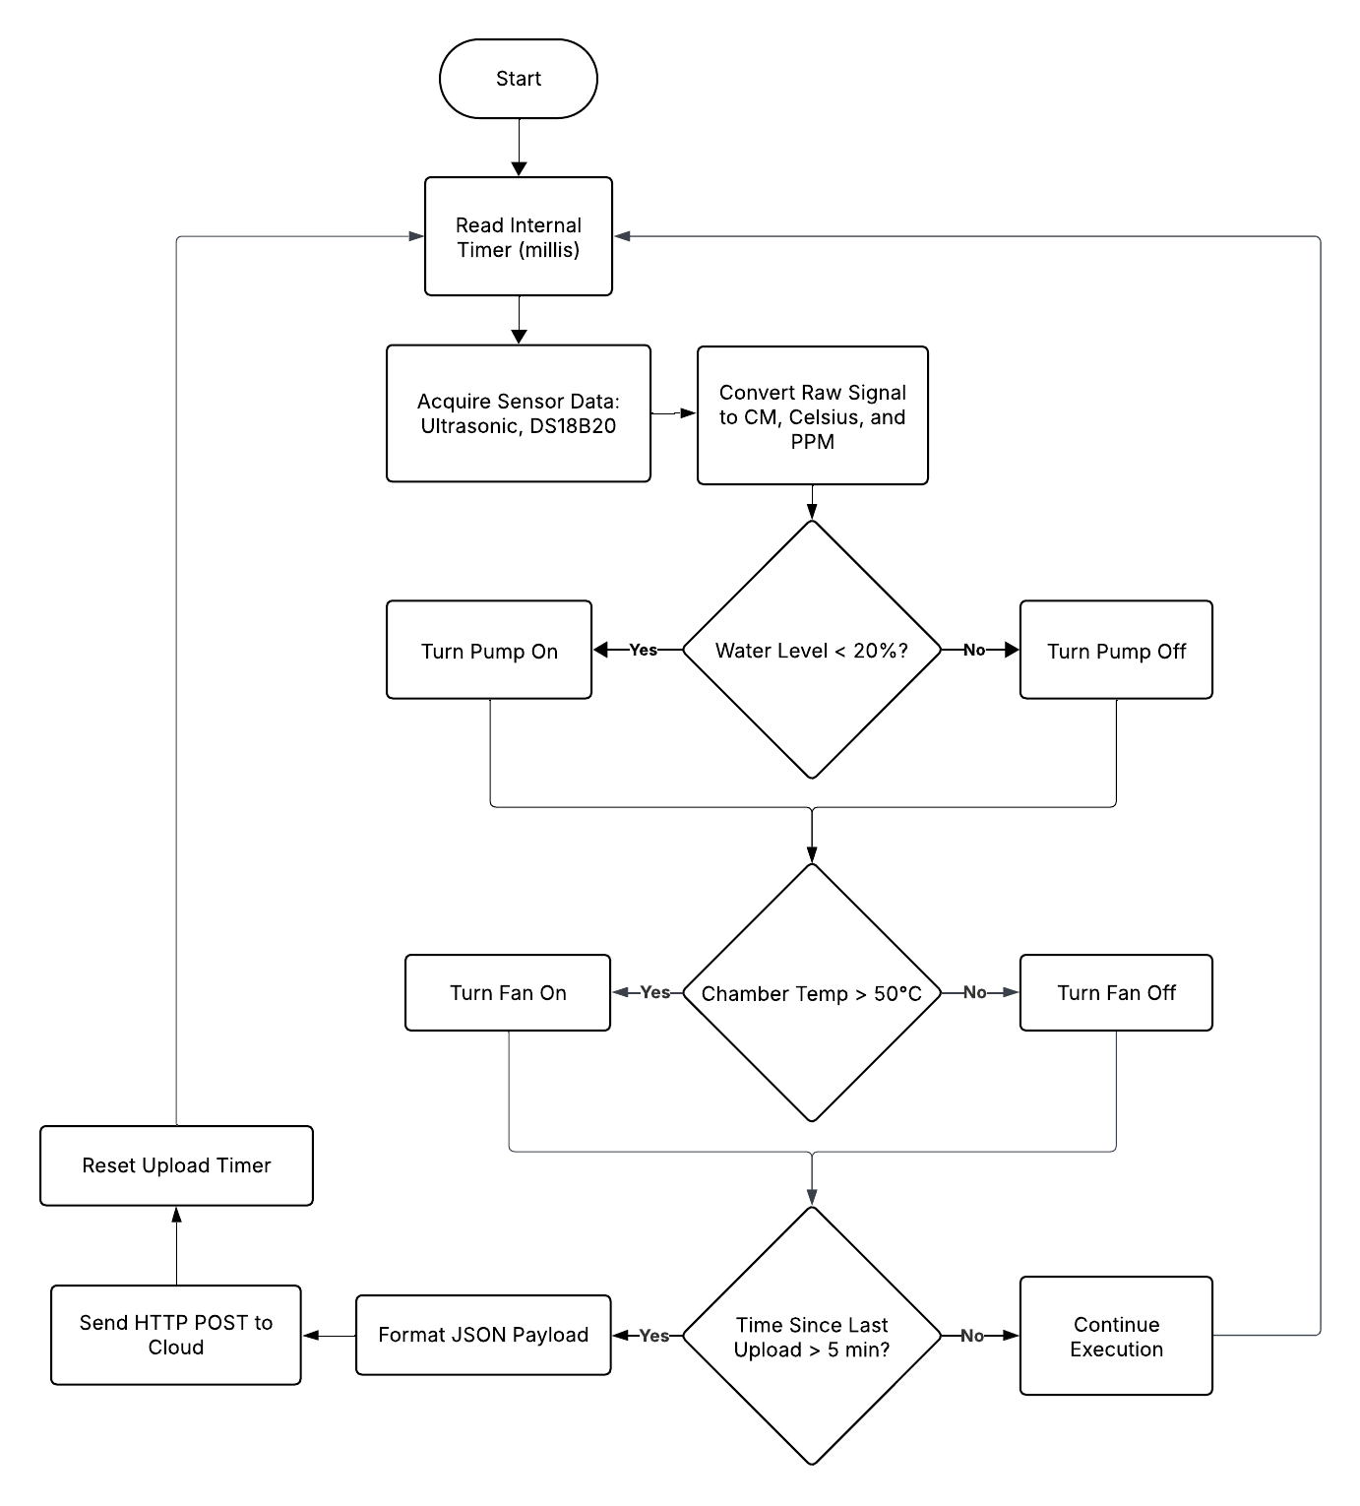
Figure 3.1 Main Control Loop Logic
Figure 3.1 illustrates the internal firmware logic, structured as a non-blocking Finite State Machine (FSM). The execution cycle begins at Connector A by reading the internal system timer and acquiring raw data from the sensor array, which are immediately processed and converted into standard engineering units (Centimeters, Celsius, and PPM). The logic then proceeds sequentially through three decision blocks. First, the Refill Check evaluates if the water level is below the 20% threshold; if true, the Pump Relay is driven HIGH, otherwise, it is explicitly set LOW to prevent overflow. Next, the Thermal Check compares the chamber temperature against the 50°C setpoint, driving the Fan Relay HIGH if the threshold is exceeded to assist condensation. Finally, the Telemetry Check minimizes bandwidth usage by verifying if the 5-minute upload interval has elapsed. If the timer condition is met, the system formats a JSON payload and executes an HTTP POST request to the cloud; otherwise, it skips transmission and loops back to the start immediately.
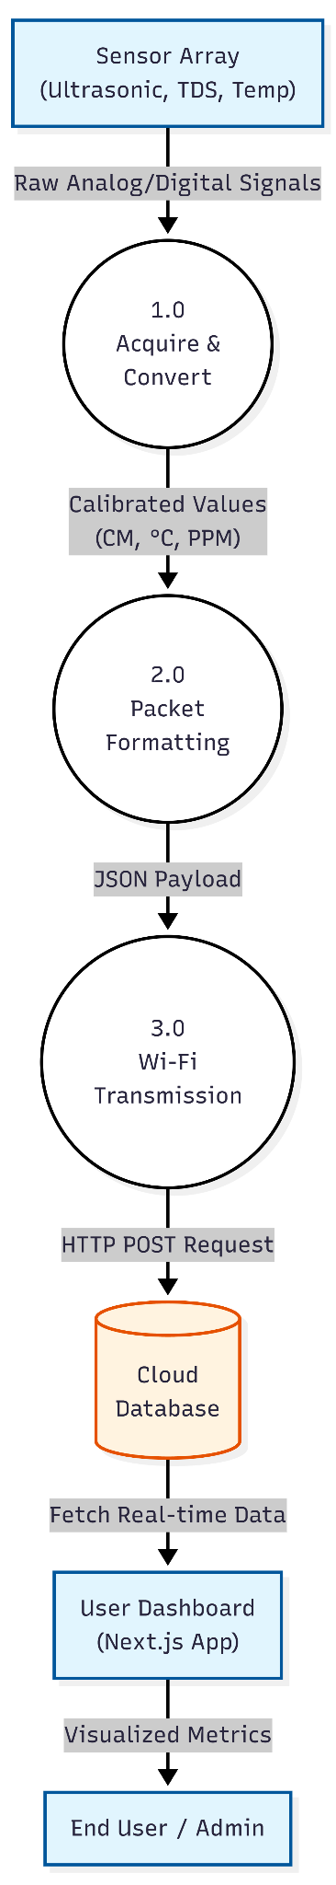
Figure 2.6 System Data Flow Diagram
The Data Flow Diagram (Figure 3.2) tracks the complete lifecycle of information within the Project WALRUS ecosystem. The process originates at the Physical Hardware Layer, where the sensor array generates raw analog and digital signals corresponding to environmental parameters. These signals are ingested by the ESP32 microcontroller (Process 1.0), which converts them into human-readable metrics. Once processed, the firmware encapsulates this data into a standardized JSON object (Process 2.0). The Wi-Fi Transmission Module (Process 3.0) then transmits this payload via a secure HTTP POST request to the Cloud Database. Finally, the User Dashboard (developed in Next.js) queries this database to render real-time visualizations for the End User, completing the information feedback loop.
2.6 TESTING AND DATA GATHERING
2.6.1 Testing Strategy 1
This strategy is designed to test the energy self-sufficiency and operational reliability of the WALRUS unit’s Power and Control Subsystems over a full operational cycle.
The data to be gathered for this test includes the Battery Voltage (V), which will be measured every 30 minutes from the 12V Lead-Acid Battery via the Control Subsystem, and the Solar Panel Current (A) and Power (W), which will be measured at the output of the Solar Panel and logged by the Charge Controller. Additionally, the Microcontroller and Sensor Current Draw (A) will be estimated or measured once during the steady-state "Idle" and "Monitoring" phases. Finally, the System State will be logged, specifically tracking events for transitions between states (Idle, Refilling, Distilling) as determined by the Finite State Machine (FSM).
Gathering this data is critical to validate the project's ability to operate off-grid. The battery voltage and solar charging data directly prove that the solar photovoltaic system is appropriately sized to meet the device's energy demand under real-world, intermittent conditions. Logging the system state confirms that the FSM logic is correctly interpreting the power status, such as stopping operations if battery voltage is too low, and prioritizing charging during high-irradiance periods.
The primary goal is to prove that the Power Subsystem can maintain the 12V Lead-Acid Battery above its critical discharge threshold (e.g., 11.5V) for a full 24-hour cycle, ensuring the device can operate indefinitely without external charging. This validates the design choice of the 20W-50W Solar Panel, the Charge Controller, and the 7Ah battery.
2.6.2 Testing Strategy 2
This strategy focuses on validating the core function of the WALRUS unit: the efficient conversion of seawater into potable water and the purity of that water.
The data to be gathered for this test includes the Basin Temperature (°C) and Condenser Temperature (°C), which will be measured continuously by the DS18B20 Digital Sensors. The purity will be assessed by measuring the Distillate Total Dissolved Solids (TDS) (ppm) using the Analog TDS Sensor for a sample of the collected distillate water. Furthermore, the Water Level (cm) will be measured by the Ultrasonic Sensor (HC-SR04) to track the evaporation rate over time, and the Total Volume of Distillate (mL) will be measured by physically collecting and quantifying the output over a set period (e.g., 8 hours).
Temperature data (Basin and Condenser) is crucial for calculating the system's thermal efficiency and correlating it with the "Accelerated Condensation" action from the Cooling Fan. The TDS reading is the definitive measure of the project's success in purification, as it must meet a specific standard for potable water (e.g., typically < 500 ppm). The volume collected is the practical metric for the unit's throughput or daily capacity.
The results aim to prove two key claims. First, the Purity Target is to demonstrate that the desalinated water consistently achieves a TDS reading below the accepted limit for drinking water, validating the solar distillation process. Second, the Performance goal is to prove that the system can produce a quantifiable volume of clean water (e.g., X Liters per day) and demonstrate an increase in the condensation rate (evidenced by a greater temperature difference between the basin and condenser) when the Cooling Fan is actively engaged, validating the Electromechanical Actuation Subsystem's purpose.

